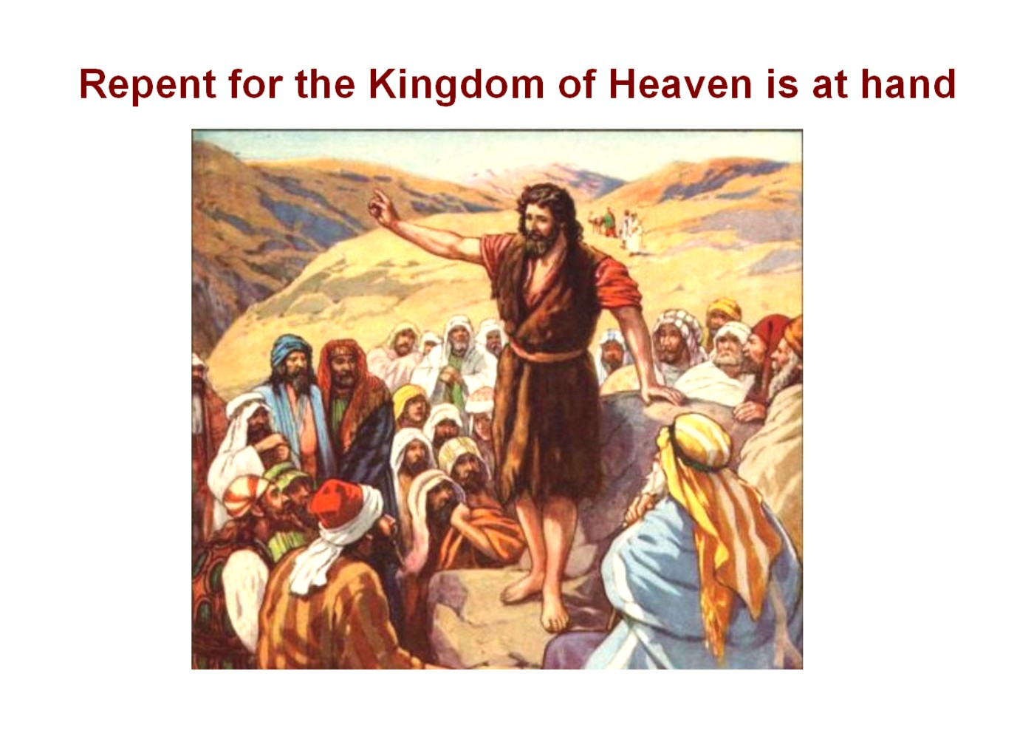
Greetings in the name of our Lord and Savior Jesus Christ,
Thank you for your consideration of these words of encouragement in your service to our Lord Jesus. The scriptures in this card help us to understand the need for “Repentance” in our own life. When Jesus spoke to the multitudes about the Kingdom of God, He spoke in parables. In the
parable of The Sower, Matthew 13, Jesus explains the meaning of this parable to those who have “eyes to see” and “ears to hear”. He tells us that we must be given those “spiritual” eyes and “spiritual” ears in order to understand what the parable says. And Jesus tells us exactly how we may obtain these spiritual eyes and spiritual hears.
Jesus began to preach, "Repent, for the kingdom of heaven is near." MT 4:17
“Most assuredly, I say to you, unless one is born of water and the Spirit, he cannot enter the kingdom of God. That which is born of the flesh is flesh, and that which is born of the Spirit is spirit. Do not marvel that I said to you, ‘You must be born again.’ The wind blows where it wishes, and you hear the sound of it, but cannot tell where it comes from and where it goes. So is everyone who is born of the Spirit.” John 3:5-7
The next card will list additional scriptures about “Repentance from Dead Works”.
In His service «Email_Address»
«First_Name» «Last_Name» «Address_Line_1» «City», «State» «ZIP_Code»
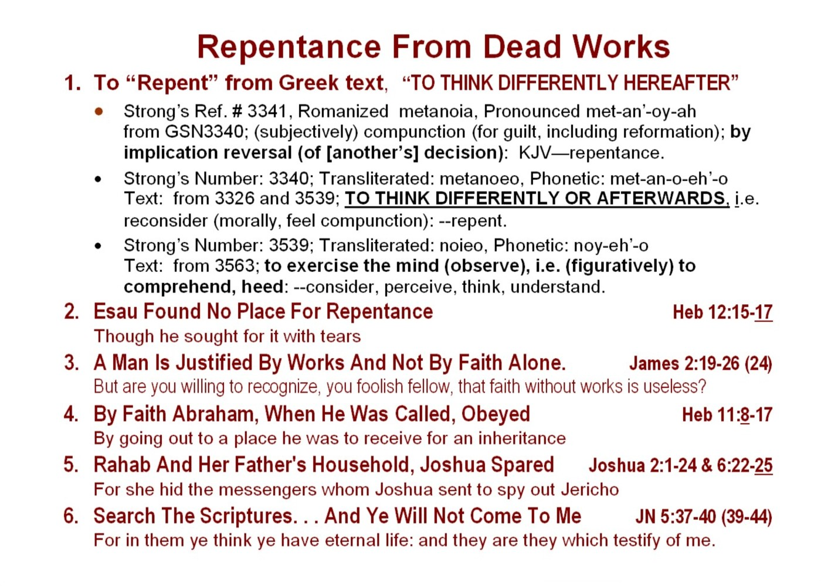
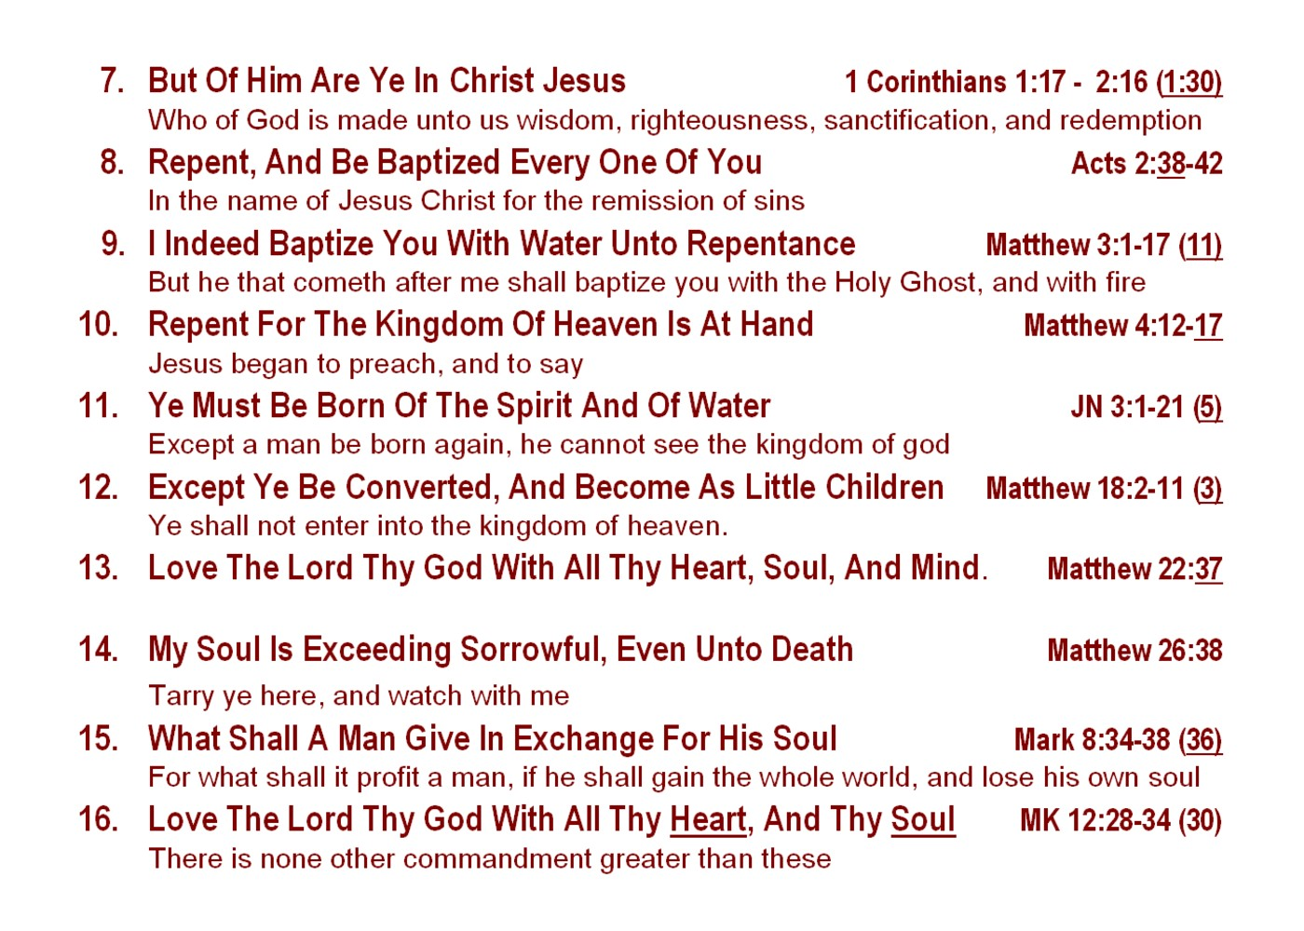
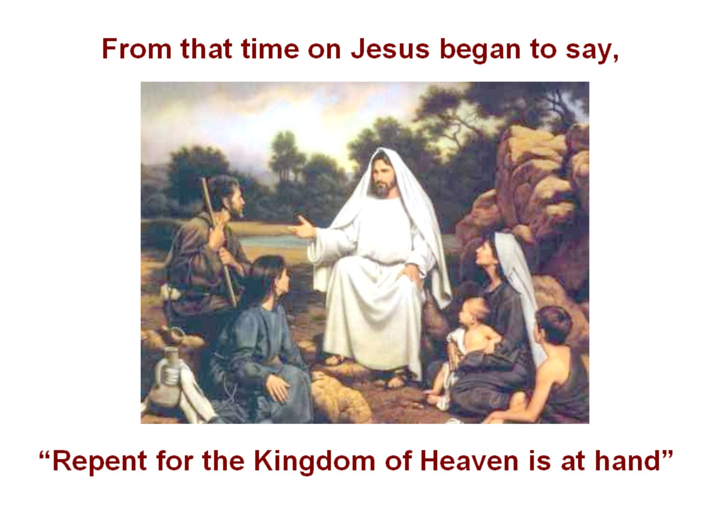
Greetings in the name of our Lord and Savior Jesus Christ,
Thank you for your consideration of these words of encouragement in your service to our Lord Jesus. The scriptures in this card continue to help us to understand the need for “Repentance”.
It is important for every true believer in Jesus Christ to understand that there
are three parts to his and her existence here on earth. Everyone who is born is given a “body” which Jesus says is our “flesh”. And we are also given a “soul” which He says is our “carnal mind”. But Jesus tells us there is needed yet a third part of us to be gained which is our “spirit”, not to be confused with the Holy Spirit. And In order for us to be given this new baby spirit, Jesus tells us we must be “born again”. He further tells us, speaking through Paul, that this new birth happens when we are “saved”.
“The Word is near you, it is in your mouth and in your heart…That is if you confess with your mouth that Jesus is Lord and believe in your heart that God has raised Him from the dead you will be saved. For it is with your heart that you believe and are justified and it is with your mouth that you confess and are saved…. Everyone who calls upon the name of the Lord will be saved” Romans 10:8-13
The next card will list scriptures concerning “Faith Toward God”.
In His service «Email_Address»
«First_Name» «Last_Name» «Address_Line_1» «City», «State» «ZIP_Code»
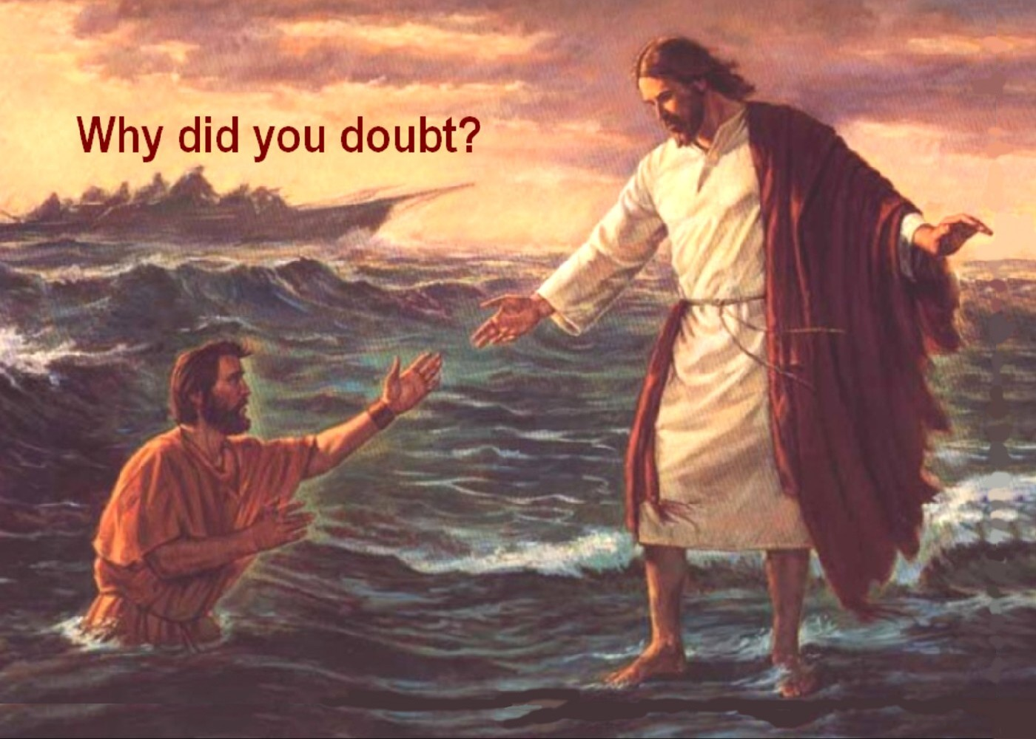
Greetings in the name of our Lord and Savior Jesus Christ,
Thanks again for your prayerful consideration of these words of encouragement in your service to our Lord Jesus. The scriptures in this card help us to understand the need for “Faith towards God”. Indeed faith is the very “currency” that makes things happen in the Kingdom of God. Jesus tells us of the importance of faith when He says to us,
Believe me when I say that I am in the Father and the Father is in me; or at least believe on the evidence of the miracles themselves. I tell you the truth, anyone who has faith in me will do what I have been doing. He will do even greater things than these, because I am going to the Father. And I will do whatever you ask in my name, so that the Son may bring glory to the Father John 14:11-13
Now faith is the substance of things hoped for, the evidence of things not seen….Without faith it is impossible to please him: for he that cometh to God must believe that he is, and that he is a rewarder of them that diligently seek him
Heb 11:1 & 6
….blessed are they that have not seen, and yet have believed. John 20:29
The next card will list additional scriptures about “Faith towards God”.
In His service «Email_Address»
«First_Name» «Last_Name» «Address_Line_1» «City», «State» «ZIP_Code»
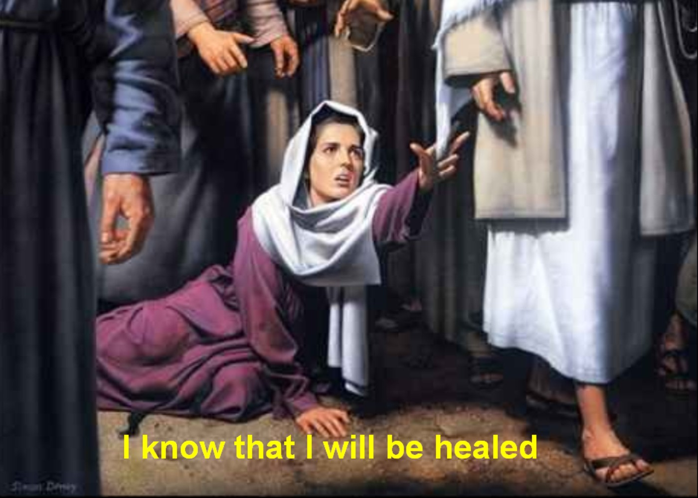
Greetings in the name of our Lord and Savior Jesus Christ,
Thanks again for your continued prayerful consideration of these words of encouragement in your service to our Lord Jesus. The scriptures in this card continue to help us understand the need for “Faith towards God”. Jesus tells us of the importance of faith when He says this to us even today.
Afterward He appeared to the eleven themselves as they were reclining at the table; and He reproached them for their unbelief and hardness of heart, because they had not believed those who had seen Him after He had risen. And He said to them,
"Go into all the world and preach the gospel to all creation. He who has believed and has been baptized shall be saved; but he who has disbelieved shall be condemned.”
"These signs will accompany those who have believed: in My name they will cast out demons, they will speak with new tongues; they will pick up serpents, and if they drink any deadly poison, it will not hurt them; they will lay hands on the sick, and they will recover." Mark 16:14-19
The next card will list scriptures concerning “Baptism in Water for Repentance“.
In His service «Email_Address»
«First_Name» «Last_Name» «Address_Line_1» «City», «State» «ZIP_Code»
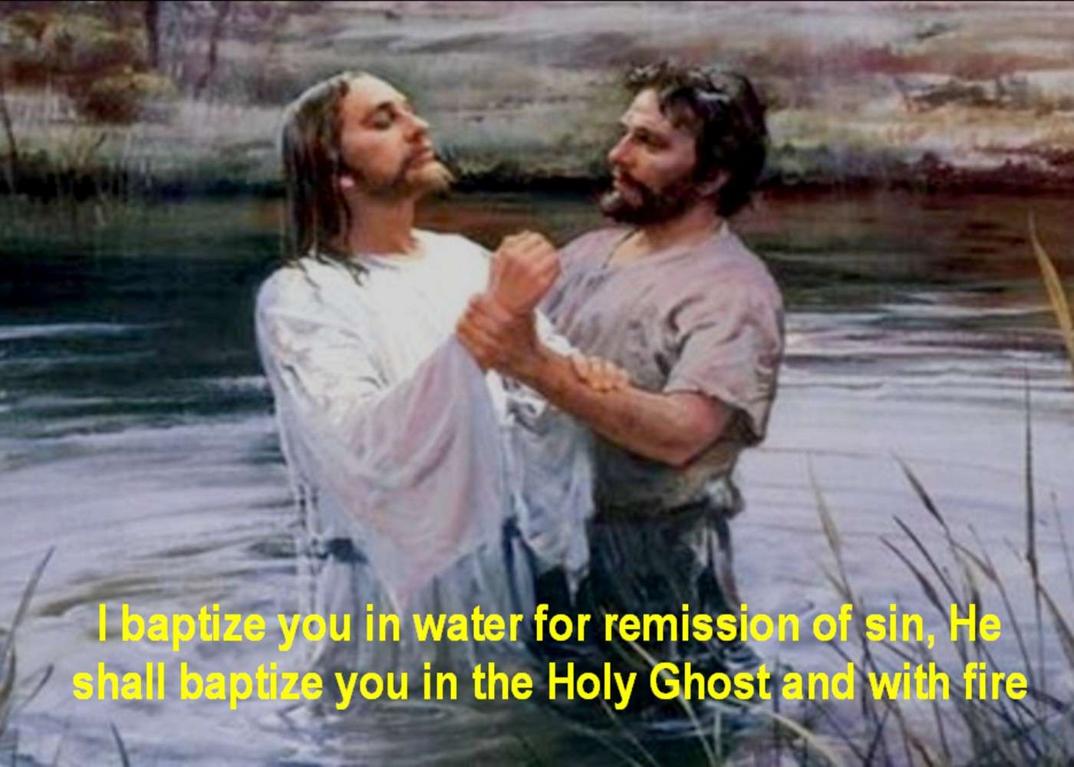
Greetings in the name of our Lord and Savior Jesus Christ,
In our ministry and service to the Lord Jesus, may I offer these words of encouragement from Him about the need for each of us to be baptized in water for repentance. Jesus, speaking to us through John the Baptist, Peter and Paul tells us of the importance of learning about three different baptisms. They are (1) the baptism of water, (2) the baptism in the Holy
Spirit, and (3) the baptism of fire. This card lists scriptures that speak of the first of the three baptisms, “The Baptism in Water for Repentance”.
Of special importance are references 7 and 8 which relate the baptism in water as a “separation” or “putting off” of the body of the flesh, also referred to as the “sinful nature” or the “old man”. This is important in growing up spiritually into the “new man” that Jesus intends for us to become. Also let us consider the admonition of Jesus speaking to us through Peter regarding the things that accompany salvation.
Paul, according to the wisdom given him, wrote to you, as also in all his letters, speaking in them of these things, in which are some things hard to understand, which the untaught and unstable distort, as they do also the rest of the Scriptures… but grow in the grace and knowledge of our Lord and Savior Jesus Christ To Him be the glory, both now and to the day of eternity. 2 Peter 3:15-18
The next card will list the scriptures concerning “ The Baptism of the Holy Spirit ”.
In His service «Email_Address»
«First_Name» «Last_Name» «Address_Line_1» «City», «State» «ZIP_Code»

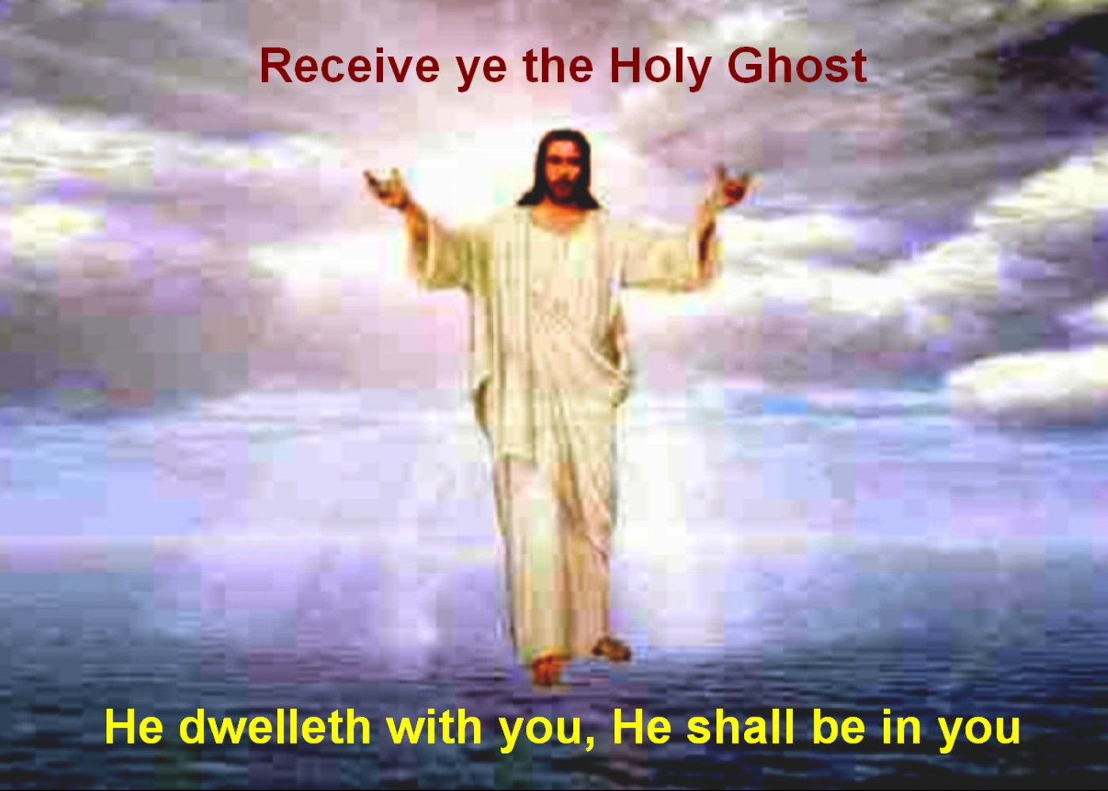
Greetings in the name of our Lord and Savior Jesus Christ,
In our ministry and service to the Lord Jesus, may I offer these words of encouragement from Him about the need for each of us to be baptized. Jesus speaks to us of three baptisms. He tells us, speaking through John the Baptist, Peter and Paul, of the need for every true believer in Him to learn about and to receive all three of these baptisms. They are (1) the baptism of
water, (2) the baptism in the Holy Spirit, and (3) the baptism of fire. This card lists the scriptures that speak of the second of the three baptisms, “ The Baptism in the Holy Spirit ”.
“I say unto you, ask and it will be given to you, seek and you will find, knock and the door will be opened to you. For everyone who asks, receives”. . . . .
“If you then, though you are evil, know how to give good gifts to your children, how much more will your Father in heaven give the Holy Spirit to those who ask Him.”
Luke 11:9 and 13
Again Jesus said, "Peace be with you! As the Father has sent me, I am sending you." And with that he breathed on them and said, "Receive the Holy Spirit. John 20:19-21
The next card will list scriptures concerning “ The Baptism of Fire ”.
In His service «Email_Address»
«First_Name» «Last_Name» «Address_Line_1» «City», «State» «ZIP_Code»
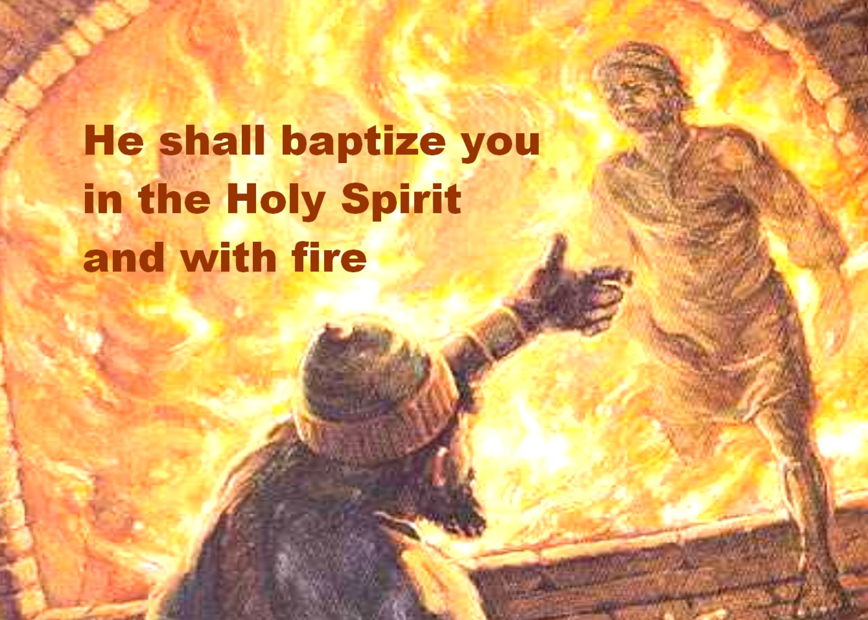
Greetings in the name of our Lord and Savior Jesus Christ,
In our ministry and service to the Lord Jesus, may I offer these words of encouragement from Him about the need for each of us to be baptized. However Jesus speaks to us of three baptisms. He tells us, speaking through John the Baptist, Peter and Paul, of the need for every true believer in Him to learn about and to receive all three of these baptisms. They are (1) the
baptism of water, (2) the baptism in the Holy Spirit, and (3) the baptism of fire. This card lists the scriptures that speak of the third of the three baptisms, “The Baptism of Fire”.
Therefore I urge you, brethren, by the mercies of God, to present your bodies a living and holy sacrifice, acceptable to God, which is your spiritual service of worship. And do not be conformed to this world, but be transformed by the renewing of your mind, so that you may prove what the will of God is, that which is good and acceptable and perfect
Romans 12:1-2
Each man's work will become evident; for the day will show it because it is to be revealed with fire, and the fire itself will test the quality of each man's work. If any man's work which he has built on it remains, he will receive a reward. If any man's work is burned up, he will suffer loss; but he himself will be saved, yet so as through fire. 1 Corinthians 3:13-15
The next card will list scriptures concerning “ The Gifts of the Holy Spirit ”.
In His service «Email_Address»
«First_Name» «Last_Name» «Address_Line_1» «City», «State» «ZIP_Code»
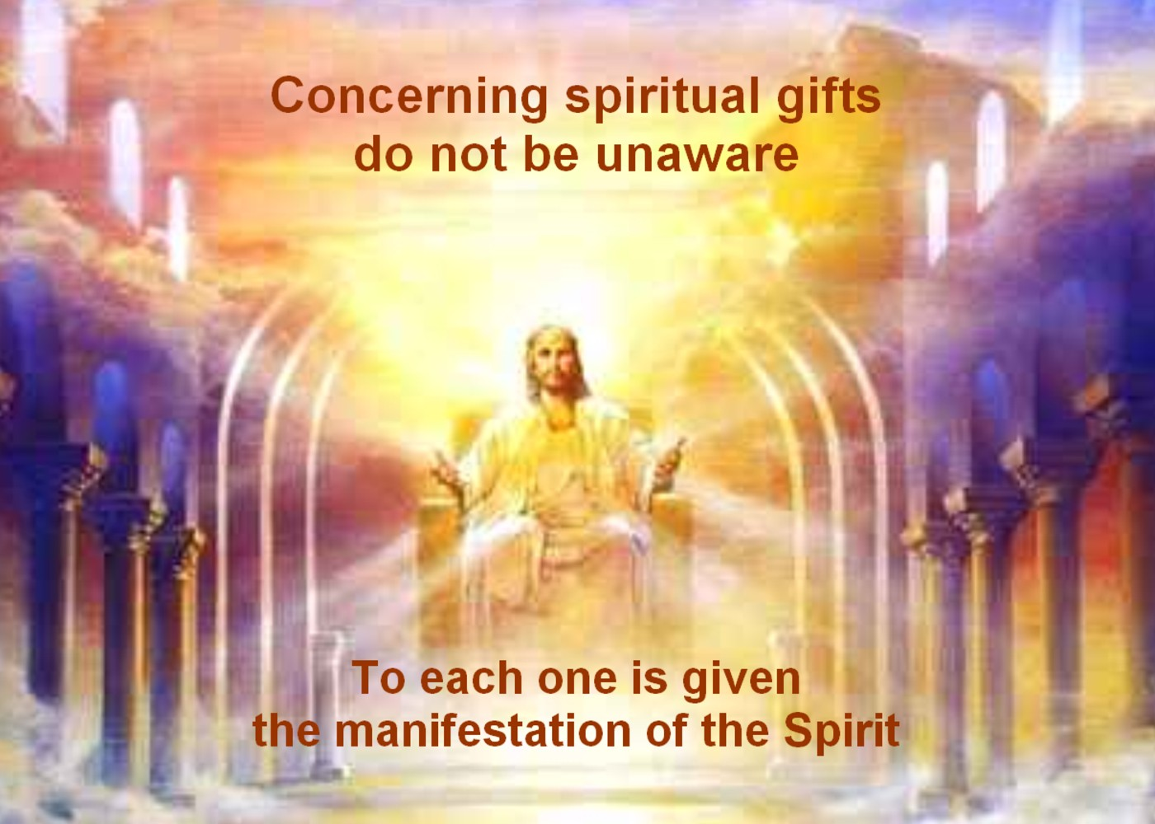
Greetings in the name of our Lord and Savior Jesus Christ,
Jesus, John the Baptist, Peter and Paul all speak of the importance of learning about three different baptisms. They are (1) the baptism of water, (2) the baptism in the Holy Spirit, and (3) the baptism of fire. These are scriptures that speak to us of the importance of being endued with power from on high. This power that Jesus has given to us is that we may be
more effective in doing the work of the ministry in preaching the gospel of Jesus Christ to every creature. It is important for us to be equipped with the power of the Holy Spirit that we may be able to “ disciple the nations ” as Jesus has commanded. Jesus says:
“ These signs shall follow those that believe. In My name they will cast out demons, they will speak with new tongues; they will pick up serpents, and if they drink any deadly poison, it will not hurt them; they will lay hands on the sick, and they will recover. ” Mark 16:15 - 20
“ Do not despise prophetic utterances. But examine everything carefully; hold fast to that which is good and discard that which is evil.” 1 Thes 5:15-22
The next sequence of cards includes scriptures about the remaining three foundational truths of the doctrine of Jesus. These are (4) Laying On Of The Hands, (5) The Resurrection Of The Dead, And (6) The Eternal Judgment
In His service «Email_Address»
«First_Name» «Last_Name» «Address_Line_1» «City», «State» «ZIP_Code»
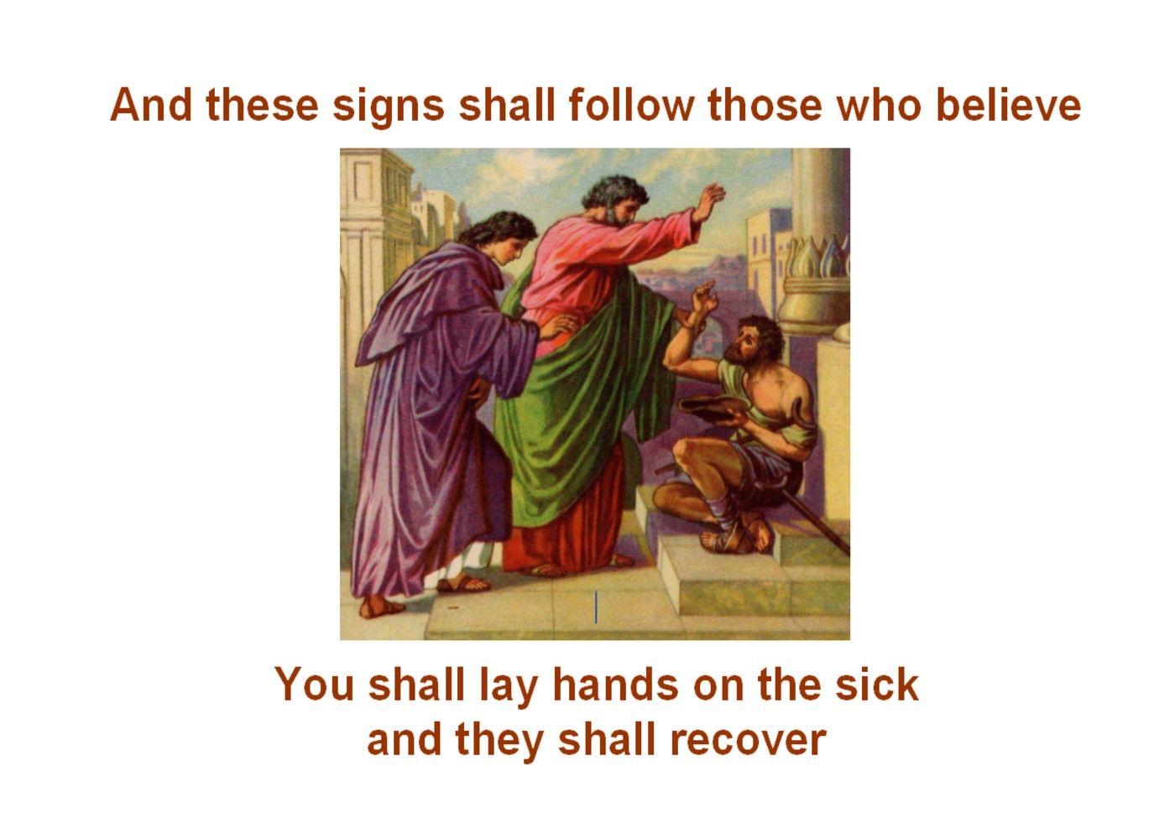
Greetings in the name of our Lord and Savior Jesus Christ.
Our Lord Jesus was very specific about His going with us in His charge to us to preach the gospel to all creatures. He said it is His intention to confirm these words we speak with signs and wonders following.
“Go into all the world and preach the gospel to every creature. He
who believes and is baptized will be saved; but he who does not believe will be condemned.”
“And these signs will follow those who believe: In My name they will cast out demons; they will speak with new tongues; they will take up serpents; and if they drink anything deadly, it will by no means hurt them; they will lay hands on the sick, and they will recover.”
So then, after the Lord had spoken to them, He was received up into heaven, and sat down at the right hand of God. And they went out and preached everywhere, the Lord working with them and confirming the word through the accompanying signs. Amen. MK 16:15-20 (NKJV)
The next album will list scriptures about “ The Resurrection of the Dead ”.
In His service «Email_Address»
«First_Name» «Last_Name» «Address_Line_1» «City», «State» «ZIP_Code»
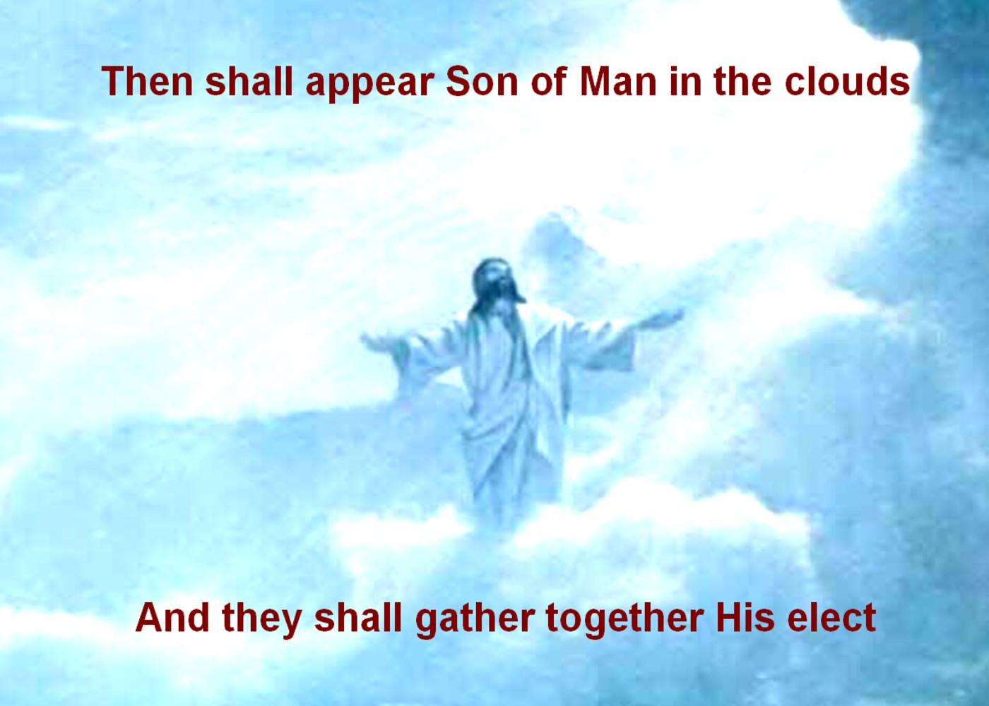
Greetings in the name of our Lord and Savior Jesus Christ,
And now comes that most encouraging word that Jesus is coming again to receive you and I in the clouds. What a great word to comfort each other with in these difficult and trying times.
Now when He had spoken these things, while they watched, He was
taken up, and a cloud received Him out of their sight. And while they looked steadfastly toward heaven as He went up, behold, two men stood by them in white apparel, who also said, “Men of Galilee, why do you stand gazing up into heaven? This same Jesus, who was taken up from you into heaven, will so come in like manner as you saw Him go into heaven.” Acts 1 NKJV
And I saw, and behold, a white cloud; and on the cloud I saw one sitting like unto a son of man, having on his head a golden crown, and in his hand sharp sickle. And another angel came out from the temple, crying with a great voice to him that sat on the cloud, Send forth thy sickle, and reap: for the hour to reap is come; for the harvest of the earth is ripe. And he that sat on the cloud cast his sickle upon the earth; and the earth was reaped. Rev 14:14-16 KJV
The next card of this series lists scriptures that speak of “ The Eternal Judgment.”
In His service «Email_Address»
«First_Name» «Last_Name» «Address_Line_1» «City», «State» «ZIP_Code»
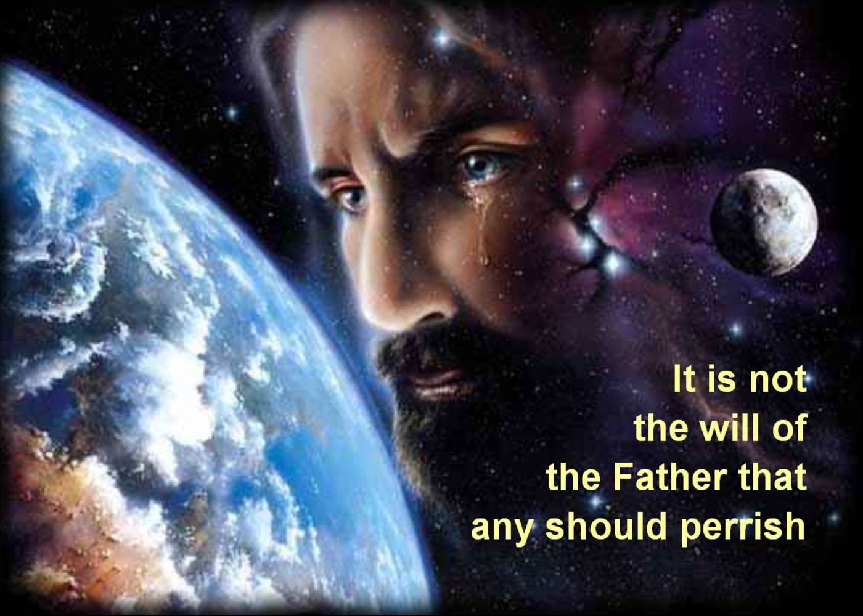
Greetings in the name of our Lord and Savior Jesus Christ,
The Eternal Judgment is the last of the six basic oracles of God, The Milk of the Word. Consider these words of Jesus
He that rejecteth me, and receiveth not my words, hath one that judgeth him: the word that I have spoken, the same shall judge him in the last day. For I have not spoken of myself; but the Father which
sent me, he gave me a commandment, what I should say. Matthew 12:48-50
And speaking through His disciple John we are told this:
Then I saw a great white throne and Him who sat on it, from whose face the earth and the heaven fled away. And there was found no place for them. And I saw the dead, small and great, standing before God, and books were opened. And another book was opened, which is the Book of Life. And the dead were judged according to their works, by the things which were written in the books. The sea gave up the dead who were in it, and Death and Hades delivered up the dead who were in them. And they were judged, each one according to his works. Then Death and Hades were cast into the lake of fire. This is the second death. And anyone not found written in the Book of Life was cast into the lake of fire. Rev 20:11-15 NKJV
The next two cards are a Review Summary of scriptures referenced for those oracles.
In His service «Email_Address»
«First_Name» «Last_Name» «Address_Line_1» «City», «State» «ZIP_Code»
Greetings in the name of the Lord and Savior Jesus Christ,
Congratulations. Having now completed this first series of cards listing the Milk of God's Word, I invite you to continue with the next series of cards having to do with the
Meat of God's Word. They will assist you in helping others
grow in their spiritual maturity and understanding of "The Way of Righteousness". Just send me your request by mail or by email and I will send you those cards in the same way as before.
If you are interested in learning how you may create and send your own cards for any occasion such as these you have received I invite you to visit my web site listed below. After viewing a short video, you may create and send your own card as my gift to you . May God bless you.
«First_Name» «Last_Name»
«Address_Line_1»
«City», «State» «ZIP_Code»
«Email_Address»

